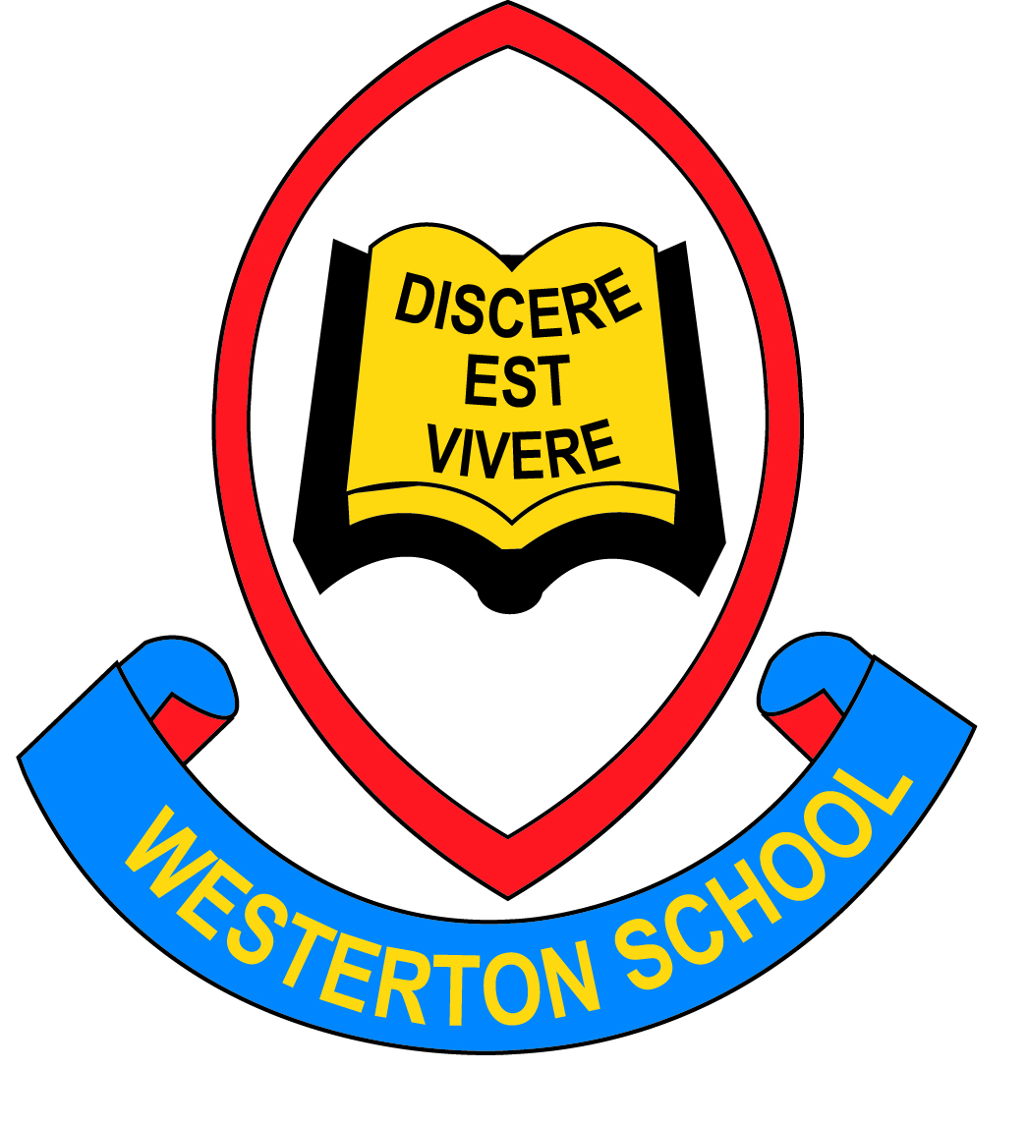

**Westerton**

**Primary School**

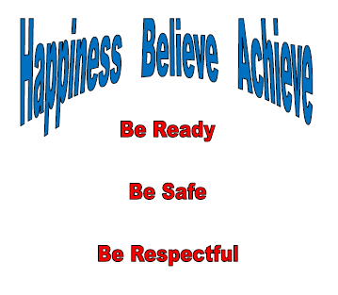

**Anti-Bullying & Positive Relationships Policy**



**Anti-Bullying & Positive Relationships Policy**

February 23

*‘Respect for All has a fundamental role to play in helping us realise our vision for all children and young people. It provides a holistic framework for all adults working with children and young people to address all aspects of bullying, including prejudice-based bullying. Respect for All reflects Getting it Right for Every Child (GIRFEC) and recognises that bullying impacts on wellbeing. In order to thrive and achieve their full potential, children and young people need learning environments which are safe, nurturing, respectful and free from fear, abuse and discrimination’.*

*Scottish Government (2017) – Respect for All: A National Approach to Anti-Bullying for Scotland’s Children and Young People.*

***Rationale***

These Anti-Bullying guidelines provide guidance to pupils, staff and parents of Westerton on preventing, responding to and reducing bullying behaviour in line with East Dunbartonshire’s Anti-Bullying Policy and Guidance for Educational Establishments 2022

**Aims:**

Westerton Primary is committed to providing a safe and supportive environment for all children and young people and we promote a culture where bullying is recognised as being unacceptable.

Bullying behaviour is not, and should never be, an inevitable part of school life or a necessary part of growing up.

The success of any anti-bullying policy requires a clear response for schools and guidance on how to prevent, respond to and reduce bullying behaviours. Current research has shown that bullying is a likely cause of stress for children and young people and has a direct correlation with poor mental health.

We aim to:

* provide leadership and ensure accountability through systematic monitoring and review of data;
* support establishments working with children and young people to develop a positive and inclusive ethos and culture;
* support effective policies and practices which proactively prevent and deal with all types of bullying behaviour;
* ensure provision of information, training, advice and support to those working with children and young people as well as their parents or carers;
* ensure a co-ordinated and cohesive response to bullying across the authority.

All staff directly working or involved with children and young people will aim to:

* develop positive relationships amongst children, young people and adults which are mutually respectful, responsible and trusting; and promote their emotional health and wellbeing;
* build capacity, resilience and skills in children and young people, and parents and carers, to prevent and deal with bullying;
* prevent bullying of children and young people through a range of policies, strategies and approaches;
* support children, young people and their parents and carers who are affected by bullying

The Scottish Government is committed to supporting and promoting children's rights and the **United Nations Convention on the Rights of the Child (UNCRC)**. All children and young people have these rights and should respect the rights of others. The UK has ratified the UNCRC and Scotland participates in reporting every five years on its implementation of the convention, including its action on anti- bullying.

There is also a strong UK and Scottish legal framework which enshrines the welfare of the child as paramount. While taking into consideration the views of the child, the framework secures an adequate and efficient provision of education which is directed to the development of the personality, talents and mental and physical abilities of the child or young person to their fullest potential.

**The Education (Additional Support for Learning) (Scotland) Act (2004, amended 2009)** requires local authorities to reduce barriers to learning, which can include bullying behaviour.

The Health and Wellbeing framework within Curriculum for Excellence complements the duty in the **Schools (Health Promotion and Nutrition) (Scotland) Act 2007** for Scottish Ministers and local authorities to endeavour to ensure that all schools are health promoting. The statements of experiences and outcomes in Health and Wellbeing reflect a holistic approach to promoting the health and wellbeing of all children and young people, and are the responsibility of all teachers. Health promoting schools will promote the mental, emotional, social and physical health and wellbeing of all children and young people.

**Getting it Right for Every Child (2008)** highlights eight wellbeing indicators to ensure that all children and young people are Safe, Happy, Achieving, Nurtured, Active, Respected, Responsible and Included.

**The Equality Act (2010)** aims to strengthen the law to support progress on equality. The Act consolidates and harmonises a range of equality legislation, replacing familiar laws such as the Sex Discrimination Act 1975, the Race Relations Act 1976 and the Disability Discrimination Act 1995. The Act provides protection from discrimination, harassment and victimisation based on a range of 'protected characteristics'. The Act protects people from discrimination on the basis of the following protected characteristics:

* disability
* gender reassignment
* pregnancy and maternity
* race
* religion or belief
* sex
* sexual orientation

The protected characteristics of age and marriage and civil partnership apply to schools as employers but not in relation to provision for pupils.

**The Children and Young People (Scotland) Act** 2014 is a key part of the Scottish Government's strategy for making Scotland the best place in the world for children to grow up. By facilitating a shift in public services towards the early years of a child's life, and towards early intervention whenever a family or young person needs help, the legislation encourages preventative measures, rather than crises' responses. Underpinned by the Scottish Government's commitment to the United Nations Convention on the Rights of the Child 1989 (UNCRC), and the national approach, Getting it Right for Every Child (GIRFEC), the 2014 Act also establishes a new legal framework within which services are to work together in support of children, young people and families.

**Education (Scotland) Act 2016** requires strategic planning to consider socio-economic barriers learning. It includes provisions which extend the rights of children aged 12 and over with capacity under the Additional Support for Learning Act. Children who are able to can use rights on their own behalf to affect decision making about them.

**Child Poverty (Scotland) Act** 2017 sets ambitious income targets for child poverty reduction for 2030. Consultation on the child poverty bill identified children’s experience of poverty can lead to bullying or feelings of exclusion, as they may have fewer friends and less access to the social activities of their peers.

**East Dunbartonshire Council’s Equality and Human Rights Policy (2011-2014)** sets out the Council’s commitment to the principles of equality, diversity and human rights for all.

East Dunbartonshire Council is committed to ensuring that anti-bullying advice and guidance is fully informed by this legal framework, in particular the ‘protected characteristics’ from the Equality Act. Bullying experiences bring a loss of opportunity for the person (s) to grow and develop and are often linked with prejudice and discrimination.

**Definitions of Bullying**

Bullying is both behaviour and impact; the impact is on a person’s capacity to feel in control of themselves. This is what we term as their sense of ‘agency’. Bullying takes place in the context of relationships; it is behaviour that can make people feel hurt, threatened, frightened and left out. This behaviour happens face to face and online (Respect Me, 2015).

These behaviours can take place in schools, children's services, residential services, at home and in the community, at youth groups and out of school care and can come from children, young people and adults.

Significantly, although online bullying has become much more prevalent in recent years and is taken as seriously as any other form of bullying, face to face bullying is still the most common. Online bullying occurs in the virtual world which children and young people access through the Internet, via social networking (eg Facebook,Twitter and Snapchat), computers and mobile phones. As communication can happen anywhere and at any time, often unsupervised, on-line bullying can be very pervasive and difficult to handle. However, in essence, the behaviour is the same and requires similar prevention methods.

Bullying - A Guide for Parents and Carers, which includes guidance on on-line bullying, is available from ‘respectme’–Scotland’s Anti-bullying Service on their website.

Bullying behaviour may be related to prejudice-based attitudes and behaviours which may compound other differences or difficulties in a child or young person’s life. These include:

* gender reassignment
* pregnancy & maternity
* racist bullying
* religion and belief
* homophobic bullying
* disablist bullying;
* body image;
* sexism and gender;
* looked after children and young people;
* young carers;
* socio-economic group

With this in mind, vulnerable children and young people may be particularly at risk of experiencing bullying.

Descriptions of prejudice-based bullying are included in **Appendix 1**.

Research and practice experience over time have led to an emerging understanding of bullying as a behaviour which emerges from complex social dynamics rather than solely as a characteristic of the individual. Bullying can be understood as behaviour which leaves people feeling helpless, frightened, anxious, depressed or humiliated.

When talking about bullying, it is important not to label children and young people as ‘bullies’ or ‘victims’. Labels can stick for life and can isolate a child, rather than helping them to recover or change their behaviour. All children and young people need help to understand why bullying behaviour is wrong in order that they can change it.

East Dunbartonshire Council is committed to current definitions that take account of the context in which the event took place and the impact on the person who feels harm has been done to them. It is considered unhelpful to define bullying purely in terms of behaviours alone.

It is important to have clarity about these significant events and be able to recognise and acknowledge bullying behaviours when they happen.

Bullying behaviours can include:

* name calling, teasing, putting down or threatening and intimidating by making prejudiced-based remarks;
* hitting, tripping, pushing, kicking;
* taking and damaging belongings;
* ignoring, excluding, spreading rumours;
* sending abusive messages electronically, eg via text, emails or social networking sites;
* making people feel like they are being bullied or fearful of being bullied;
* targeting someone because of who they are or who they are perceived to be.

This list is not an exhaustive list; there may be other behaviours that could impact negatively on a child’s wellbeing.

It is crucial to take into account the impact that bullying behaviour has on a child or young person. The impact an incident has on a child or young person is more important than whether it is classified as bullying. Actions can affect people in different ways and this should be taken into consideration. The person who has experienced harm may have experienced just one event. The impact determines the definition of bullying. One incident is sufficient to alert adults to take supportive action.

Not every unkind behaviour constitutes bullying. Children and young people are still learning how to get along with others. They will tease each other, fall in and out with each other, have arguments, stop talking to each other and disagree about what they like and don’t like. These are examples of ordinary conflict, perhaps thoughtlessness and possibly insensitive behaviour and should be viewed as a normal part of growing up. However, if left unchecked, these behaviours can lead to bullying, making those being bullied feeling afraid, uncomfortable or unsafe in their environment. They should be viewed as an opportunity to help children and young people learn about resolving conflict and getting along with others. Parents, teachers and other adults need to model kindness, conflict resolution, inclusion and responsibility.

**Communicating Awareness**

In order to tackle the issue of bullying it is essential that **everyone within the community** is aware that **bullying is never acceptable** and what action should be taken if they are subject to, or witness, what might be a bullying incident.

At Westerton Primary we will:

* Highlight anti-bullying behaviours with pupils.
* Establish an ethos of mutual respect through reinforcing expectations of good behaviour.
* Develop an awareness of our Westerton Expectations – ‘Be Ready, Be Safe, Be Respectful’
* Update our school values with all stake holders and ensure these are embedded with all. Happiness Believe Achieve
* Encourage the effective communication of any bullying incidents
* Confirm that we will respond to bullying behaviour quickly and seriously
* Ensure events such as Anti-Bullying week and Odd Socks Day are included within our diversity calendar

It is essential that everyone takes responsibility in creating a safe and supportive environment within Westerton Primary and we aim to achieve this by:

* Encouraging pupils and staff to take action if they see bullying behaviours.
* Through our HWB programmes.
* Effective playground supervision.
* Promoting inclusive games in the playground. (Playpals)
* Providing worry boxes – where pupils can express their concerns confidentially if they feel they cannot talk about the problem.
* Ensuring that pupils are aware of the consequences of bullying.
* Run afterschool and lunchtime activity clubs to encourage further social interaction.
* Providing a ‘Respect Me’ approach
* Use of ‘Fix it Frogs’ by all supervising staff
* Use of Pivotal scripts to ensure consistency and help children feel safe at all times
* Use of restorative practice

**Prevention of Bullying**

At Westerton Primary we work to create a positive and supportive ethos. We aim to create a culture that encourages respect, values opinions, celebrates differences and promotes positive relationships therefore making it difficult for bullying behaviour to occur or be tolerated. This includes approaches such as:

* buddying or mentoring;
* peer mediation;
* system which identifies vulnerable pupils and takes steps to remedy this;
* creative and motivational ways to engage pupils and raise awareness of bullying with theatre groups, speakers, film footage and music;
* involvement of the Pupil Council;
* anti-bullying campaigns, posters, assemblies;
* encouraging pupils to report bullying incidents using ‘worry’ boxes and the school Intranet;
* areas of special focus eg prevention of name calling;
* an understanding of the impact and legal consequences of on-line bullying, supported by campus police, for the whole school community through the curriculum, assemblies and events for parents and carers.

Establishments will ensure that their Anti-Bullying Guidelines make it clear to whom allegations of bullying behaviour should be reported by staff, children and young people and parents and carers.

When an incident has been raised, the designated member of the senior management team should log the incident on the SEEMIS Bullying & Equalities module as soon as possible. An investigation into the incident should follow and SEEMIS should be updated throughout this process. Once concluded, the incident should be closed off.

Where the allegation is unfounded, recording of the pupil’s name alleged to have been displaying bullying behaviour should be entered in the bottom box headed ‘other person’ within the ‘person displaying’ section on SEEMIS. This will ensure that the allegation will not show on the pupil’s SEEMIS record.

Where an incident is found to be bullying, the designated member of staff should ensure that appropriate supports/interventions are in place to address any underlying prejudice. It is important to ensure that notes taken during the investigation or discussions with children and young people, parents and carers are recorded on SEEMIS pastoral notes to provide a chronology of events and actions taken, as soon after the event as possible.

Establishments should ensure that staff, children and young people and parents and carers are familiar with the requirements of their Anti-Bullying Guidelines and that its terms and implications are discussed on a regular basis by various means and in relation to each establishment’s own ethos in terms of vision and values.

This can be delivered through:

* the wider curriculum (ie not restricted to the Health and Wellbeing curriculum);
* assemblies;
* classroom practice, eg circle time;
* leaflets/posters – various sources;
* induction and transition programmes;
* family workshops/education sessions;
* staff in-service/training programmes;

**Reporting Bullying Behaviour**

When an incident has been raised, the designated member of the senior management team should log the incident on the SEEMIS Bullying & Equalities module as soon as possible. An investigation into the incident should follow and SEEMIS should be updated throughout this process. Once concluded, the incident should be closed off.

Where the allegation is unfounded, recording of the pupil’s name alleged to have been displaying bullying behaviour should be entered in the bottom box headed ‘other person’ within the ‘person displaying’ section on SEEMIS. This will ensure that the allegation will not show on the pupil’s SEEMIS record.

Where an incident is found to be bullying, the designated member of staff should ensure that appropriate supports/interventions are in place to address any underlying prejudice. It is important to ensure that notes taken during the investigation or discussions with children and young people, parents and carers are recorded on SEEMIS pastoral notes to provide a chronology of events and actions taken, as soon after the event as possible.

If you are being bullied or witness someone else being bullied it is **very important that you take action**: ignoring it can often mean it will get worse!

Steps you can take include:

* Report any incident to a member of staff, class teacher or member of SLT
* Tell a friend, parent or family member.
* Use the worry box

**What will we do when you tell us?**

Steps we will take will include:

* Listen and reassure that the problem will be addressed
* Investigate fully by talking to all parties involved
* Take appropriate course of action and implement strategies
* Review outcome of action

We will encourage mediation which will involve:

* Restorative Practice
* Discussing what happened
* Discovering why the pupil became involved
* Establishing the wrong doing and the need to change
* Offering a resolution for moving forward
* Informing parents/carers or guardians to help change the attitude and behaviour of the child.

**Action**

The member of staff to whom the incident is first reported, or who has witnessed the incident, should take the incident seriously. They must use their professional judgement in deciding upon appropriate action based on the impact of the bullying behaviour on the child or young person.

The child or young person who has experienced bullying behaviour will receive appropriate support and protection.

Examples of good practice include:

* the child or young person is taken to a comfortable place with no distractions;
* the child or young person is listened to;
* the member of staff should confirm that bullying is never acceptable; they deserve to feel safe;
* they should be gently encouraged to talk, to find out what happened, who was involved,

**Anti-Bullying Policy & Guidance**

where and when – and notes taken;

* they should be asked what they want to see happen next;
* the child or young person should be kept up to date with progress;
* details of the bullying behaviour and actions taken is recorded in the SEEMIS Bullying and Equalities Module;
* the member of staff should inform parents of the incident and action taken, if it is judged to be appropriate.

In relation to the final bullet point, an example where it may not be appropriate to inform parents could include a transgender young person. The young person may not have told their family about their gender identity and inadvertent disclosure could cause needless stress for them or put them at risk.

Confidentiality and privacy should be respected and disclosing information to parents or carers should only be done with consent of the young person. Further guidance can be accessed in the following link:

<https://www.lgbtyouth.org.uk/media/1344/supporting-transgender-young-people.pdf>

When a child or young person has displayed bullying behaviour, a member of the establishment’s management team should, based on their professional judgement, endeavour to manage the resolution of the bullying incident within the school. Parents should be involved when their active support is needed to implement a resolution of the bullying incident.

Examples of good practice include:

* time should be taken to understand the reasons for the bullying behaviour;
* the individual or group should not be labelled as ‘bullies’, name the behaviour;
* staff should be prepared for a strong reaction from parents and carers, children and young people;
* staff should be prepared to address prejudicial attitudes that may be behind the bullying behaviour;
* addressing what is happening behind the behaviour, even when the bullying has stopped.

Consideration should be given to the sanctions and support given to the young person displaying bullying behaviour to ensure that interventions are intended to improve behaviour.

Such approaches might include:

* positive behaviour strategies with an appropriate member of staff, as agreed;
* restorative approaches;
* solution orientated approaches;
* involvement of educational psychologists and campus police.

However, ‘where it is considered that in all circumstances to allow the child or young person to continue attendance at school would be seriously detrimental to order and discipline or the educational wellbeing of the pupils there’ (national guidance on the prevention and management of exclusions, *Included, Engaged and Involved-Part 2* (June 2017)), senior managers have the power to exclude as a last resort.

**Recording and Monitoring**

Accurate recording of incidents of bullying using the SEEMIS Bullying and Equalities Module allows Westerton Primary to ensure that appropriate response and follow-up has been carried out, in line with the local authority’s equality duty to monitor incidents of bullying. It also helps Westerton Primary to monitor the effectiveness of its guidelines and practice and identify any need for training.

**Equality Impact**

This policy is in accordance with East Dunbartonshire Council’s Equality Impact Toolkit, 2012.

**Policy Review**

This policy will be reviewed during session 2025 to 2026.

**Acknowledgement**

This document was produced in partnership with Lorraine Glass, Partnership Manager, ‘respectme’. Content from the website of ‘respectme’ is included in this document – [www.respectme.org.uk](http://www.respectme.org.uk).

**Pupil Voice**

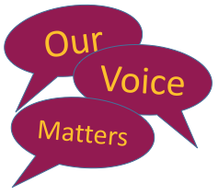This policy has been created in consultation with members of the Westerton Primary School Junior Leadership Team who say:

“We think bullying is bad. It’s important we all say no to bullying behaviour when we see it. All children at Westerton are encouraged not to be a bully. The Junior Leadership Team will help raise awareness of bullying by taking part in anti-bullying week activities and delivering school assemblies.”

“Things we think are helpful are worry boxes in all classrooms, taking part in anti-bullying week activities and letting people know about [www.respectme.org.uk](http://www.respectme.org.uk). The Junior Leadership Team intend to hold a school competition to introduce an anti-bullying mascot.”

This Policy will be reviewed in session 2025-2026